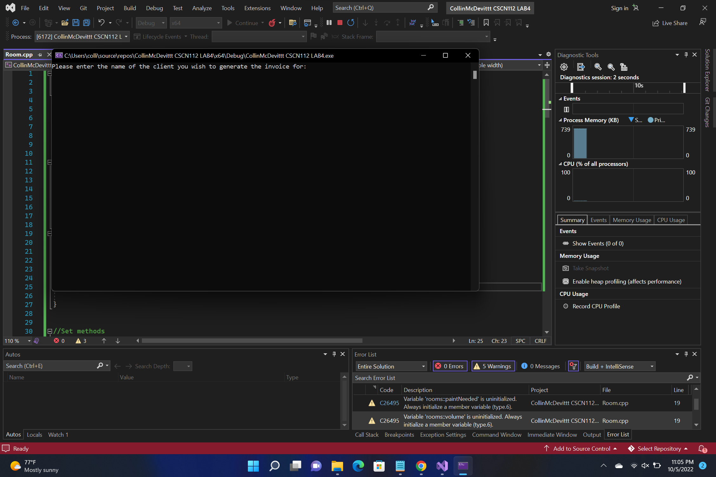

I have not shared the source code in my program with anyone other than my instructor’s approved human sources.

⦁ I have not used source code obtained from another student, or any other unaif tuthorized source, either modified or unmodified.

⦁ If any source code or documentation used in my program was obtained from another source, such as a text book or course notes, that has been clearly noted with a proper citation in the comments of my program.

⦁ I have not knowingly designed this program in such a way as to defeat or interfere with the normal operation of any machine it is graded on or to produce apparently correct results when in fact it does not.

Algorithm

Call user inputs for the name and the max number of rooms use those three to create a house object that with the three argument constructor.

Output the text for the main menu then ask for user input

If they enter an A it will check if they can add another room if so then it will prompt the user to enter the size of the room and the number of coats needed. After this it will be returned from a function then it will be added to the vector in the house class with the pushback function

If the user enters an L it will list every room object that is in the vector that is in the house object it does this by using the size vector that is in the house class and then it goes through with a for loop and uses the vector at index function and then will call the appropriate getfunction and ouput to the terminal

If the user enters a Q then it will print out the bill

If they enter a 1 then it will ask them for the name of the file that they want to ouput to if they enter a 0 the program will terminate